Wizard Reports
Chapter
5

Reports can be produced on previously created tables or queries. As with other objects in the database a report can be created from scratch or by using a Wizard. Creating a report from scratch is a very long and tedious process. It is much more efficient to create the report using a Wizard and then customise the report to look exactly how we want it.

You can create Reports based on Tables or Queries. When you base a report on a Table you can choose which fields are displayed but all records will be displayed.

If you want to display selected records depending on criteria you should create a Query first as covered in Chapter 2, then create a report based on that Query.

Objectives

In this chapter you will

- Create a Report using the Report Wizard
- Select Specific Fields to appear in a Report
- Create a Report based on a Query
- Preview a Report
- Print a Report
- Sort the Records in a Report
- Group and Summarise Records in a Report
- Create a Report on Multiple Tables

- Open the database file Ch 5 Wizard Reports

Basing a Report on a Table

- Click on the Reports tab
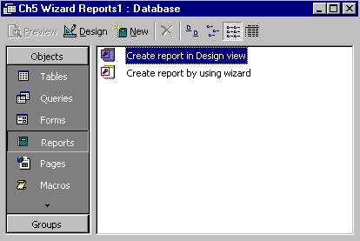
- Click on the New button
Reports tab
New

- Click on the Report Wizard Option

- Click on the droplist button for the “Choose the table or query….” box and click on the Stock table

- Click on OK to start the Wizard.
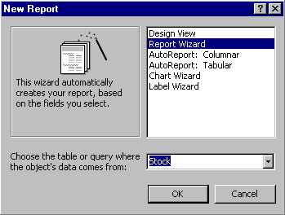
Stock
Report Wizard

This step is where the fields to be displayed on the report are selected. Not all the fields in a table have to be included.

- Click on ProductName and then click on the Select Field button
- Repeat for Product Description, SupplierID, Sell Price and No on Hand
- Click on Next
Select Field button
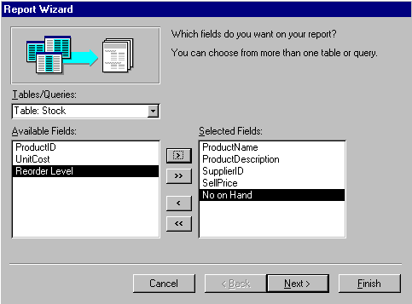
This step enables you to group the records in the report, for example by Supplier. All stock from one supplier will be listed, then by the next supplier and so on.

- Click on SupplierID and the Select Field button to Group the records in the report by Supplier (Access may have already assumed this)

- Click on Next
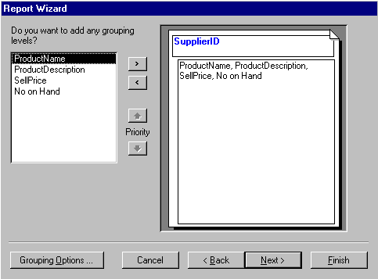

This step allows us to choose by which fields the records are ordered.

- Click on the droplist button for the first Sort box and select Product Description
- Click on the Summary Options button

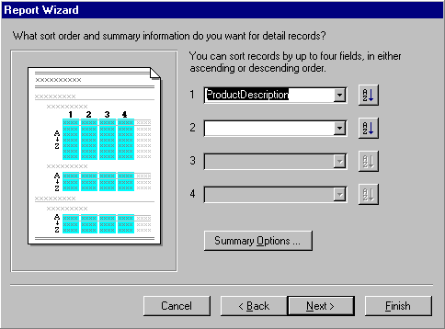
The Summary Options enables us to do simple calculations of the numerical fields
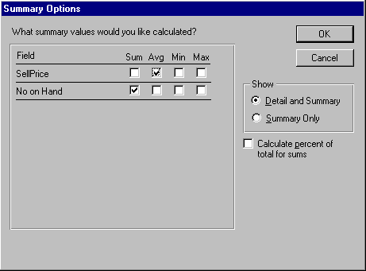
Summary Options
Summary Options

Summary Options
- Click on the Sum box for No on Hand so a total number of stock for each Supplier will be calculated

- Click on the Avg box to calculate an Average Sell Price for the Suppliers stock

- Click on OK

- Click on Next

- Select a Layout for the Report

- Click on Next

- Select a Style for the report

- Click on Next

- Enter the Title Stock on Hand by Supplier
- Check that Preview the Report is selected
- Click on Finish

The Report will appear in Print Preview as shown on the following page.

Previewing a Report

Previewing a Report is very similar to Print Preview in Microsoft Word.
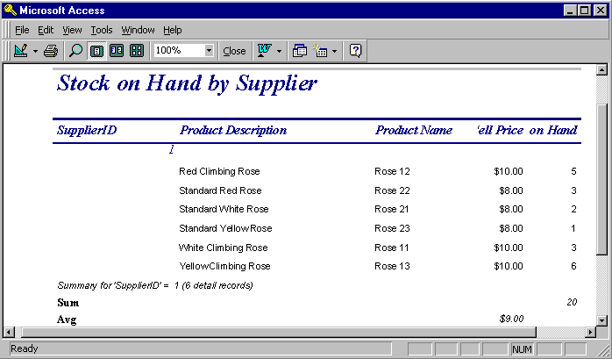
The Print Preview toolbar appears along with the preview of how the report will look when printed.

View the report Design sheet
Print the report
Magnify or reduce
One Page
Two Pages
Multiple Pages
Close and return to the Database window
Link with other Microsoft Programs
Display the Database
window
Create a new object
Activate the Office Assistant
Zoom

- Click on the Close button of the Report window to close the Report and return to Database window

The Stock on Hand by Supplier report will now be listed on the Reports tab.

Create a Report Based on a Query

Creating a Report based on a Query is the same process as when it is based on a Table however the Query is selected at the first step rather than a Table.
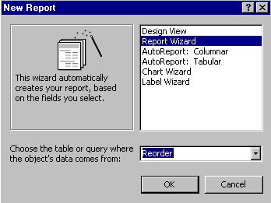
- Click on the Report tab if necessary to display it
- Click on the New button

- Click on Report Wizard
- Select the Query Reorder in the Choose the table or query…. box
- Click on OK

- Click on the Select all fields button
- Click on Next

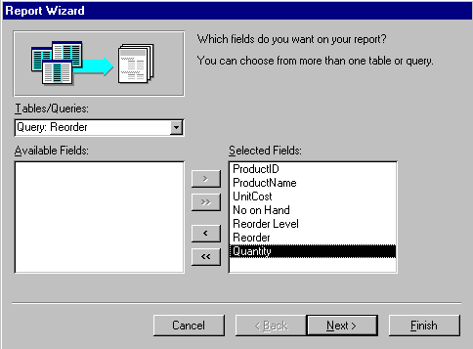
The next step is to select a record to group the records in the report by.

- Click on Reorder then Select Field
- Click on Next

- Put Product Name in the first Sort box Click on Next

- Select a Layout style for the report
- Click on Next
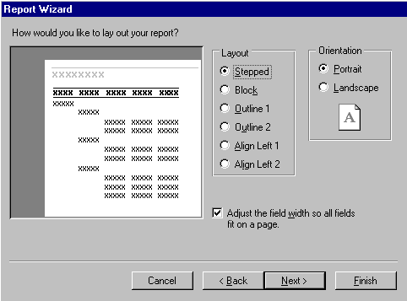
- Name the report Reorders
- Click on Finish to display the Report

- Scroll down to see the Stock to be reordered
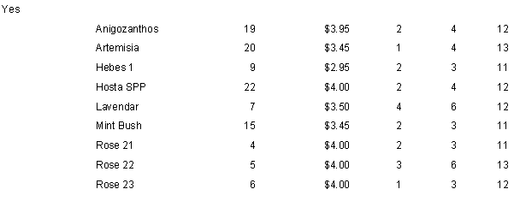
- Close the Report

Using a Report

Once a Report is created it can be used over and over again. As data changes in the tables and queries the data in the Reports will be updated as well.

- Click on the Report tab to display it
- Click on the Reorders report
- Click on Preview to display the report

Printing a Report

If a single copy of the whole report is required;

- Click on the Print button in the toolbar

If multiple copies, or specific pages of a multi-page report are required then use the Print command in the File menu.

- Click on File ➢ Print in the Menu bar
- Make selections as required and click on OK to print
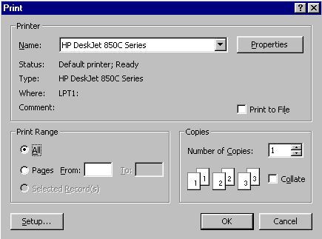
Specific Pages
Number of Copies

Creating Reports on Multiple Tables

Reports can be based on either Queries or Tables or both. When tables are related reports can be produced that include details from both tables. For example a report on customers and the details of the plants they have ordered. However it is better to create a query first then create the report based on the query.

- Click on the Reports tab
- Click on the New button
- Click on the Report Wizard
- Click on Customers in the Choose table…. Box
- Click on OK

- Click on the field Customer ID then the Select field button, then Company Name and the Select field button
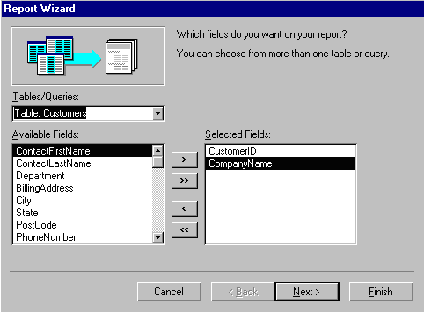

- Click on the Tables/Queries droplist button and click on Table: Orders
- Use the Select Field button to enter the fields OrderID and OrderDate

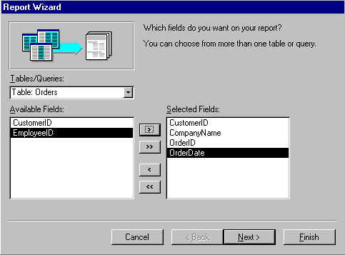
- Click on the Tables/Queries droplist button and click on Table: Order Details

- Use the Select Field button to enter the fields ProductID and Quantity
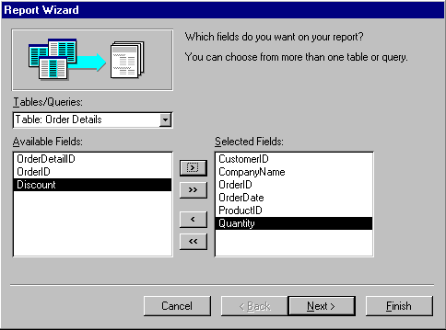

- Click on Next

This step enables you to group data in the report so that the data in a field is repeated over and over.

- Keep as by Customers and click on Next
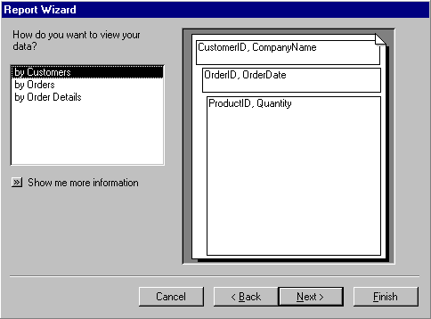

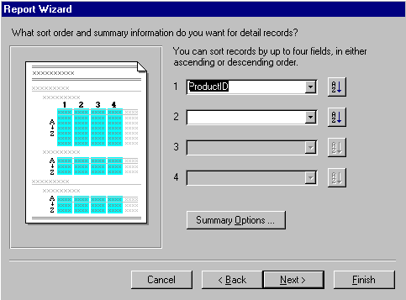
- Click on Next again
- Put Product Id in the first Sort box
- Click on Next
- Choose a Layout and click on Next

- Choose a Style and click on Next

- Enter the Report name Customer Orders and click on Finish to display the report
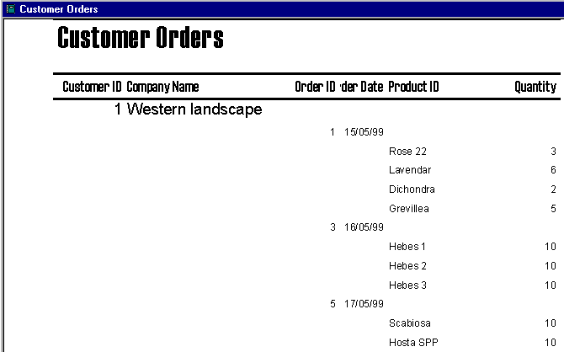
Reports created this way can be produced quickly but they often require refinement to look better and produce other relevant information. In the next chapter you will look at customizing reports.

Practice: Creating a Report based on Multiple Tables

- Use the Report Wizard to create a Report called Orders by Employee that lists for each Employee the Order ID and Order Date

Note: You should use the EmployeeID, FirstName and LastName from the Table: Employees. You should use the fields OrderID and OrderDate from the Table: Orders
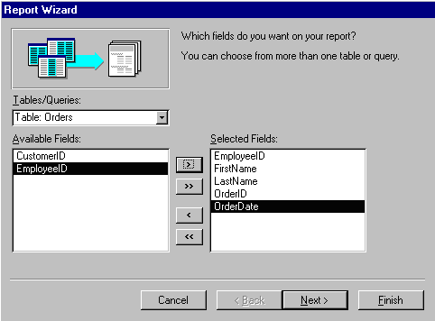
The report should look something like this.
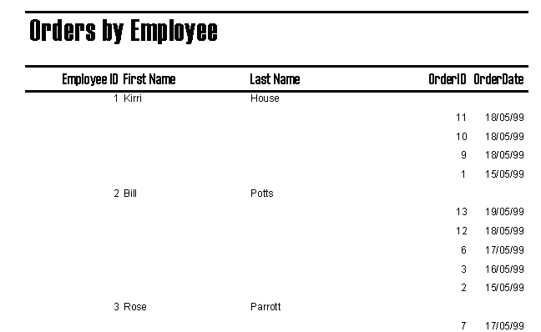
- Close the Report

